Camera-Based Automated Public Lighting with Motion Detection and Zone-Based Adaptive Control Using ESP32-CAM
Murali Mahadev Naik, Tejas H M, Mohith Poojar B E
School of Computer Science and Engineering
Presidency University, Bengaluru, India
naik89968@gmail.com

Abstract— Traditional streetlights usually stay at a fixed brightness all night, wasting significant energy when roads are empty. To address this, we developed a low-cost, camera-based public lighting prototype using an ESP32-CAM and an OV2640 camera module. The system uses lightweight frame-differencing to pick up movement, an LDR sensor to monitor ambient light, and three virtual lighting zones to deliver targeted illumination.
The onboard camera captures low-resolution frames and compares consecutive images to detect motion. Once activity is spotted, it maps the movement to the left, center, or right zone, boosting the corresponding LED's brightness while letting previously triggered zones drop back to a dim standby state. An LDR automatically handles day/night mode switching, while the ESP32-CAM manages all local processing and offers Wi-Fi connectivity for optional cloud monitoring.
Designed to run independently without needing an external PC, this prototype shows how affordable embedded hardware can deliver adaptive zone-based lighting. We evaluated the system across camera performance, motion detection, zone-mapping accuracy, LED responsiveness, and light sensing. All reported performance and energy-saving figures are backed by physical testing on the prototype, laying a clear groundwork for cost-effective, smart public lighting.
Keywords— Adaptive Public Lighting, ESP32-CAM, Motion Detection, Frame Differencing, Virtual Lighting Zones, Embedded Systems, Energy Efficiency, Internet of Things.
I. INTRODUCTION
Streetlights are essential for keeping urban areas safe and navigable, but conventional systems waste a massive amount of electricity. Running at maximum brightness all night—regardless of whether anyone is actually on the street—is an inefficient use of energy and resources. A far smarter approach is an automated system that dynamically adjusts illumination based on real-time activity. By scaling light levels to match actual human and vehicular presence, cities can dramatically curb unnecessary power usage. This shift not only slashes operational utility costs but also significantly reduces the overall carbon footprint of municipal infrastructure.
While basic motion sensors have limited coverage, camera-based sensing provides a broader, context-aware view of the environment. By using lightweight image-processing algorithms to compare sequential frames, a camera can track movement in real time and pinpoint exactly where extra lighting is needed.
To demonstrate this concept, we built a compact prototype using an ESP32-CAM module with an OV2640 camera, supported by a light-dependent resistor (LDR) for automatic day-night detection. During dark conditions, the camera captures low-resolution frames and processes them locally to identify significant movement. We divided the camera’s field of view into three virtual lighting zones, allowing the system to map detected activity directly to specific sections of the monitored area.
Instead of keeping the entire street fully lit, the system keeps the LEDs in a low-power standby mode by default. When a pedestrian or vehicle enters a specific zone, the corresponding LED ramps up to full brightness. As the activity moves along, previously triggered zones gradually dim back down to conserve energy. All core sensing, frame processing, and zone-control decisions occur locally on the ESP32-CAM chip, eliminating the need for an external computer during normal operation. This localized processing keeps operational latency virtually non-existent, ensuring lights respond instantly to fast-moving subjects.
For remote management, built-in Wi-Fi sends operational logs to a Firebase cloud database. Crucially, offloading status data to the cloud never disrupts the local board's real-time lighting adjustments. This prototype successfully integrates embedded hardware, edge computer vision, dynamic control, and cloud monitoring into an affordable, scalable package—laying the groundwork for future upgrades like machine-learning object recognition and larger multi-zone urban deployments.

II. RELATED WORK
A growing body of research explores smart, adaptive public lighting powered by sensors, embedded hardware, the Internet of Things (IoT), and computer vision. Together, these studies showcase various strategies for slashing wasted energy without compromising safety or visibility for drivers and pedestrians. Ultimately, this literature underscores a clear trend: combining localized edge processing with activity detection and cloud monitoring is key to building truly efficient municipal lighting.
Researchers in [1] proposed a traffic-aware adaptive street lighting scheme that relies on networked sensors to spot vehicles and pedestrians, dynamically tweaking brightness to match immediate activity. While their work clearly proved that real-time adjustments beat traditional static lighting at cutting power use, the design depends on a full web of distributed sensors and heavy infrastructure—a stark contrast to a compact, single-controller prototype.
The Smart Cities Adaptive Lighting System (SCALS) introduced in [2] features a flexible urban lighting setup designed to tune streetlight brightness to match live traffic and foot activity on specific road segments. By combining dedicated sensors, network communication, and dynamic controls, it delivers targeted light right where it's needed. Yet while it highlights the power of segment-based control, the architecture targets expansive city infrastructure rather than a budget-friendly, single-camera embedded prototype.
Takruri et al. [3] introduced a real-time streetlight dimming framework built on a hybrid control architecture. By tailoring illumination to live traffic and weather conditions, their system cuts energy use while offering remote monitoring and automated fault detection. A standout feature is its rely on local microcontroller processing to minimize response lag—yet it still relies on discrete external sensors for environmental and traffic data, unlike a compact edge controller running lightweight camera vision directly onboard.
A comprehensive survey on IoT-based smart public street lighting [4] explored how pairing LEDs with wireless sensors, microcontrollers, and smart communication networks enables dynamic brightness control. The review reinforces that networked sensing and adaptive control are vital for energy-efficient smart cities. However, because these platforms typically depend on dense sensor arrays or distributed networks, there remains a compelling opportunity for streamlined, single-camera solutions that can pinpoint activity directly within a monitored zone.
Sasidevi et al. [5] introduced an IoT-driven intelligent street-lighting setup that combines an STM32 microcontroller with an LDR, infrared (IR) sensors, and cloud communication. The system relies on the LDR to gauge daylight levels and IR sensors to ramp up brightness when movement is detected, all while streaming status logs to the web. While it nicely demonstrates the power of pairing ambient-light sensing with activity-based control, its motion tracking is tied to basic IR hardware and lacks the spatial accuracy of a camera-based approach.
Recent studies on adaptive street lighting have increasingly turned to computer vision. For instance, Halder and Roy [6] developed a vision-integrated prototype using a camera paired with a Raspberry Pi 5 to detect objects and track their movement. The system then adjusts lighting output based on real-time road conditions. While this underscores the strong potential of vision-driven controls, relying on a high-spec board like the Raspberry Pi along with extra hardware creates a far more compute-heavy and expensive setup than the minimalist, ESP32-CAM approach proposed here.
Križanović et al. [7] tackled adaptive street lighting from an energy-efficiency angle, testing various object-detection setups across different brightness levels. Their findings confirm that dynamic lighting slashes power consumption compared to fixed-intensity systems, though actual savings hinge on variables like object speed and control logic. However, their research centers mainly on performance modeling and simulation rather than building a physical, three-zone camera-based embedded prototype.
Altogether, these studies prove that adaptive lighting works—whether through motion detectors, environmental sensors, networked controllers, or computer vision. Yet most current setups rely on dense sensor arrays, complex network infrastructure, or heavy-duty processing hardware. Our work offers a far leaner alternative: an ESP32-CAM serving as both the main sensor and processor. By dividing the camera’s view into three virtual zones, lightweight frame-differencing pinpoints exactly where to boost brightness on the fly. An LDR handles day-night sensing, while built-in Wi-Fi and Firebase take care of cloud logging—delivering a streamlined, self-contained system.
A.Research Gap
While the literature underscores the clear benefits of dynamic lighting, activity tracking, and IoT integration, several technical gaps remain when building a low-cost embedded prototype. Basic motion-sensor systems like [5] catch movement effectively, but they cannot pinpoint where that activity is happening without cluttering the setup with extra hardware. Broader frameworks like [1] and [2] offer distributed management, yet they depend on extensive, costly infrastructure. On the flip side, vision-based approaches like [6] highlight the advantages of camera sensing, but they rely on power-hungry, high-performance computing boards.
The specific gaps addressed by our proposed system include:
- Over-reliance on heavy compute hardware: Existing vision setups depend on power-intensive processors, whereas our approach tests lightweight image processing directly on an ESP32-CAM microchip.
- Coarse spatial tracking: Standard sensor arrays detect basic presence, but they fail to determine the horizontal position of movement across a path without multiplying hardware.
- Fragmented system design: Rare integration of daylight sensing, camera tracking, edge execution, and cloud logging into one streamlined, low-power node.
- Unrefined multi-zone behavior: A lack of practical focus on simple control models that brighten the path ahead while smoothly dimming trailing lights behind moving users.
The proposed system addresses these gaps in a single integrated kiosk, as summarised in Table I.
TABLE I
COMPARATIVE SUMMARY OF EXISTING STUDIES ON ADAPTIVE PUBLIC LIGHTING SYSTEMS

Study | Platform / Technology | Detection Method | Adaptive Lighting | Zone / Location Detection | IoT / Cloud | Key Finding / Limitation
Traffic-aware lighting [1] | Networked lighting and sensors | Vehicle & pedestrian detection | Yes | Road/lighting segments | No | Demonstrates traffic-aware adaptive lighting, but requires distributed sensing infrastructure.
SCALS [2] | Smart-city adaptive lighting architecture | Vehicle & pedestrian presence | Yes | Specific road segments | Yes | Supports localized brightness control, but is designed for larger urban infrastructure.
Takruri et al. [3] | Microcontrollers + NBIoT | Traffic & environmental sensing | Yes | Distributed lighting nodes | Yes | Local control improves real-time response, but does not use camera-based zone detection.
Smart street-lighting survey [4] | IoT sensors and controllers | Sensor-based detection | Yes | Operational zones | Yes | Shows the potential of IoT-based dynamic lighting, but many approaches require multiple sensors.
Sasidevi et al. [5] | STM32 + LDR + IR sensors | Infrared motion detection | Yes | Limited | Yes | Combines ambient-light and motion-based control, but IR sensors do not provide camera-based activity location.
Halder & Roy [6] | Raspberry Pi 5 + camera + sensors | Computer-vision object detection | Yes | Object/location based | Yes | Demonstrates vision-based adaptive lighting, but requires a more powerful computing platform.
Križanović et al. [7] | Simulation + adaptive lighting models | Object detection | Yes | Object-dependent | Simulation/analysis | Shows the energy-saving potential of adaptive lighting under different operating conditions.
Proposed System | ESP32-CAM + OV2640 + LDR + 3 LEDs | Lightweight frame-based activity detection | Yes | Three virtual zones | Optional Firebase | Combines camera-based activity detection, ambient-light sensing, local zone control, and optional cloud monitoring in a compact prototype.
III. PROBLEM STATEMENT AND OBJECTIVES
Conventional public lighting systems typically operate at fixed intensity levels, keeping streetlights fully illuminated even during long stretches of inactivity. This static operation leads to substantial power waste and inefficient use of energy resources. While traditional sensor-based alternatives can detect motion, they often require multiple physical modules and still struggle to identify where that motion is happening within a monitored corridor. Consequently, there is a clear need for a localized, automated approach that adjusts light levels based on live ambient conditions and exact activity placement.
This work addresses the challenge of building a low-cost, camera-driven public lighting setup that pinpoints activity locations and adjusts zone illumination in real time. Crucially, the system must operate entirely on a compact embedded controller without relying on an external computer during standard operation. By partitioning the camera field of view into multiple virtual zones, movement detected within a specific region directly triggers its corresponding light source.

To solve this, our main objectives are to:
- Leverage an ESP32-CAM and OV2640 module for lightweight activity tracking, paired with an LDR sensor to monitor ambient day-night conditions.
- Divide the camera field of view into three virtual zones and implement frame-differencing to identify active areas without complex machine learning.
- Dynamically scale up LED brightness in the active zone while gradually dimming trailing zones back down to standby levels.
- Integrate optional Wi-Fi and Firebase cloud connectivity for remote telemetry and status logging, ensuring real-time lighting decisions remain purely on the local microchip.
IV. PROPOSED METHODOLOGY
A. System Initialization
An ESP32-CAM module integrated with an OV2640 camera sensor serves as the primary processing and sensing hub. The prototype coordinates three distinct LED clusters representing individual lighting zones across the monitored space, alongside an LDR sensor that monitors ambient light levels. Upon boot, the ESP32-CAM configures its GPIO pins for the camera interface, analog sensor reading, and PWM-based LED driving before launching the main control loop.
Under normal operating conditions, the system evaluates environmental light levels first. During daylight or high-ambient conditions, the lighting outputs remain dormant or locked at a baseline state. Once ambient light drops past a set point, the board automatically kicks off the camera-based adaptive control loop.
B. Ambient-Light Detection
The LDR sensor continuously samples ambient illuminance within the target deployment area. The microchip compares these analog voltage readings against an empirically tuned threshold to differentiate daytime from nighttime conditions.
When ambient illumination is high, the LED outputs remain completely off or locked at a minimal state. Falling light levels trigger the ESP32-CAM to switch into active activity-tracking mode. This thresholding prevents unnecessary daytime operation and conserves energy when natural light is sufficient.
C. Camera-Based Activity Detection
The OV2640 camera captures low-resolution image frames from the monitored corridor at regular intervals. Rather than running a resource-heavy deep learning or object classification model, the prototype relies on lightweight pixel-wise frame-differencing directly on the microchip.
By evaluating grayscale intensity variations between consecutive frames, any pixel changes exceeding a preset sensitivity threshold are flagged as active motion. This enables real-time activity detection without relying on external computing hardware or heavy ML inference libraries.
The primary goal of this vision loop is spatial motion tracking—it simply locates where movement is occurring across the frame rather than categorizing whether the target is a pedestrian, cyclist, or vehicle.
D. Virtual Zone Division
To map motion to localized lights, the camera's horizontal field of view is partitioned into three virtual zones:
- Zone 1: Left horizontal segment
- Zone 2: Center horizontal segment
- Zone 3: Right horizontal segment
When the frame-differencing algorithm detects motion, it calculates the horizontal centroid of the pixel changes and assigns it to the corresponding virtual zone.
For instance, movement along the left side of the frame maps directly to Zone 1, while central or rightward movement triggers Zone 2 or Zone 3, respectively. This spatial mapping allows the system to deliver targeted, localized illumination rather than wastefully driving all three light arrays at full intensity.
E. Zone-Based Adaptive Lighting Control
The detected virtual zone dictates the PWM signal sent to the matching LED cluster. In low-light conditions with no detected motion, all zones idle at a low-power standby state.
When motion registers in a specific zone, the microchip immediately ramps up the corresponding LED cluster to high intensity. As the moving target transitions into an adjacent zone, the newly target zone brightens while the previously triggered zone gradually fades back to standby.
The resulting illumination profile follows a smooth state progression:
Low-Intensity Standby⟶Activity Detected⟶Active Zone Brightens⟶Target Moves⟶Trailing Zone Fades
This control loop runs continuously, allowing light output to naturally track targets as they move through the space.
F. Local Processing and Control
The ESP32-CAM handles all frame capture, image differencing, spatial mapping, and PWM driver output onboard in real time. Because the entire processing chain runs locally on the microchip, the system functions completely independent of external computers or host servers during normal operation.
Workstations or laptops are used exclusively during development for flashing firmware, tuning thresholds, and monitoring serial telemetry. Once deployed, the node operates as a standalone edge unit.
G. Wi-Fi and Cloud Monitoring
The ESP32-CAM utilizes its integrated Wi-Fi stack to stream system telemetry to a Firebase Realtime Database. Logged metrics include active zone states, motion events, LDR light levels, and system timestamps.
Importantly, cloud communication runs asynchronously and does not participate in the core control loop. Real-time lighting adjustments execute locally on the microchip, ensuring network latency or lost Wi-Fi connections never delay light response times.
H. Overall Detection and Control Process
The execution flow begins with system startup and ambient-light verification. If natural light is sufficient, the vision pipeline remains idle. Under low-light conditions, the camera captures sequential frames and runs lightweight frame-differencing to detect motion.
When motion is detected, its horizontal position is mapped to Zone 1, Zone 2, or Zone 3, triggering the corresponding LED cluster to ramp up from standby. As the activity moves across the field of view, newly active zones brighten while trailing zones smoothly dim back down. The entire loop repeats continuously on the edge controller while background status updates sync to Firebase for remote monitoring.
ARCHITECTURE FLOW
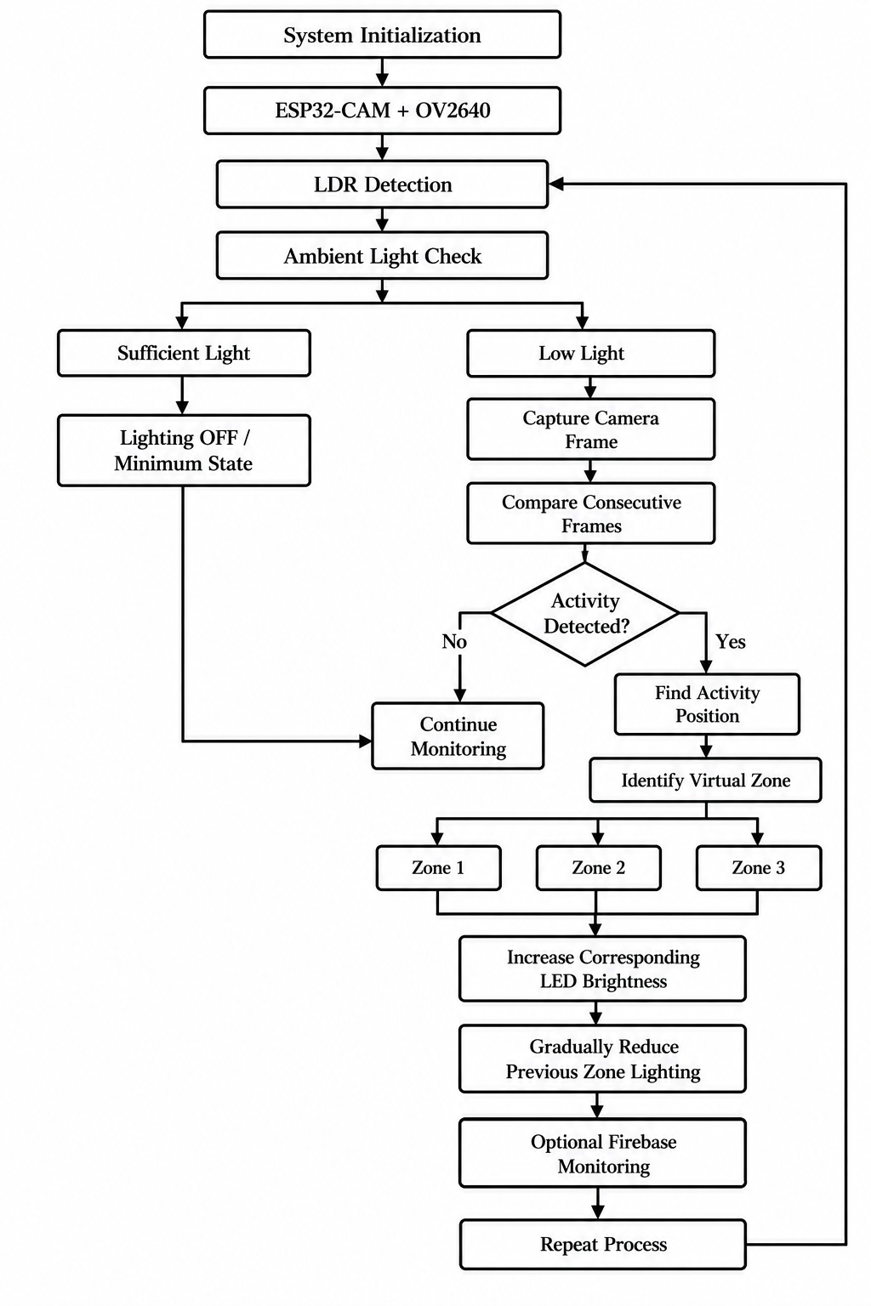Fig. 1. Proposed Architecture Flow
V. EXPERIMENTAL SETUP
A. Hardware Configuration
The experimental prototype is designed as a compact, embedded public-lighting node centered on an ESP32-CAM development board equipped with an OV2640 camera module. The ESP32-CAM was chosen as the primary control unit because it integrates a camera interface, sufficient onboard processing power, and Wi-Fi capability into a single, low-cost board. An analog LDR sensor module measures real-time ambient illuminance to differentiate between daytime and nighttime conditions.
Three discrete LEDs represent the independent lighting zones across the physical prototype setup. Each LED is wired in series with a 220 Ω current-limiting resistor to protect the microchip pins and models the lighting output for one virtual region of the monitored space. Initial breadboard prototyping relies on standard jumper leads, while a stable 5 V, 2 A power adapter supplies energy to the system via the ESP32-CAM’s micro-USB interface.
Component | Function / Role in System | Quantity
ESP32-CAM Development Board | Main microcontroller node for image processing, zone control, and Wi-Fi telemetry | 1
OV2640 Camera Module | Low-cost image sensor for real-time frame capture and motion tracking | 1
LDR Sensor Module | Analog light-dependent resistor for ambient day/night thresholding | 1
LED Indicators | Emulate individual lighting output for Zones 1, 2, and 3 | 3
220Ω Resistors | Current-limiting protection resistors for LED drivers | 3
Breadboard & Jumper Wires | Rapid prototyping connections and signal routing | 1Set
5 V, 2 A Power Adapter | External DC power source via micro-USB supply | 1
The prototype hardware will be bench-tested incrementally—first validating isolated pin responses and sensor readings before assembling the complete integrated lighting node.
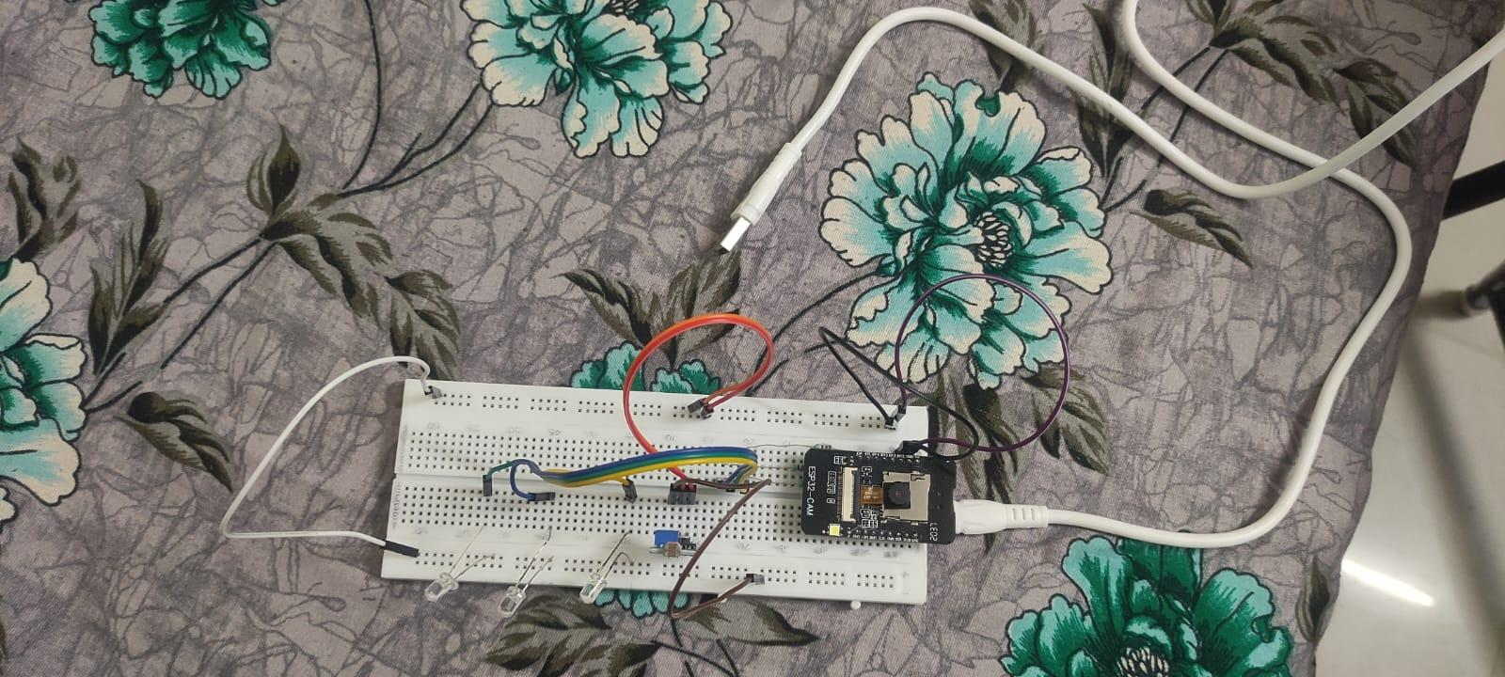
Fig. 2. Experimental hardware setup of the automated public-lighting system.
A.Prototype Implementation Status
The prototype runs on an ESP32-CAM, combining camera-based motion detection, ambient-light sensing, and zone-based LED control. The camera captures frames for motion analysis, using frame-differencing to spot changes between consecutive shots. When activity is detected, it’s mapped to one of three virtual zones, automatically adjusting the corresponding LED. A built-in LDR handles ambient light readings to switch between day and night modes.
We’ll document our progress using hardware photos, test observations, and real measurements. Any features still in development will be listed under pending work.
B. Prototype Layout
The physical testbed is modeled after a miniature roadway or pedestrian walkway divided into three contiguous lighting sections. The ESP32-CAM is mounted at an elevated vantage point to ensure its wide-angle view encompasses the entire test area. In firmware, this captured view is partitioned horizontally into three distinct virtual regions representing Zone 1, Zone 2, and Zone 3.
The three LEDs are aligned directly with these physical zones to provide immediate visual feedback. When the camera detects movement within a specific virtual segment, the microchip ramps up power to the corresponding LED, simulating targeted spotlighting. This scaled layout provides an effective bench-top environment to validate localized lighting behavior before committing to full-scale outdoor infrastructure.
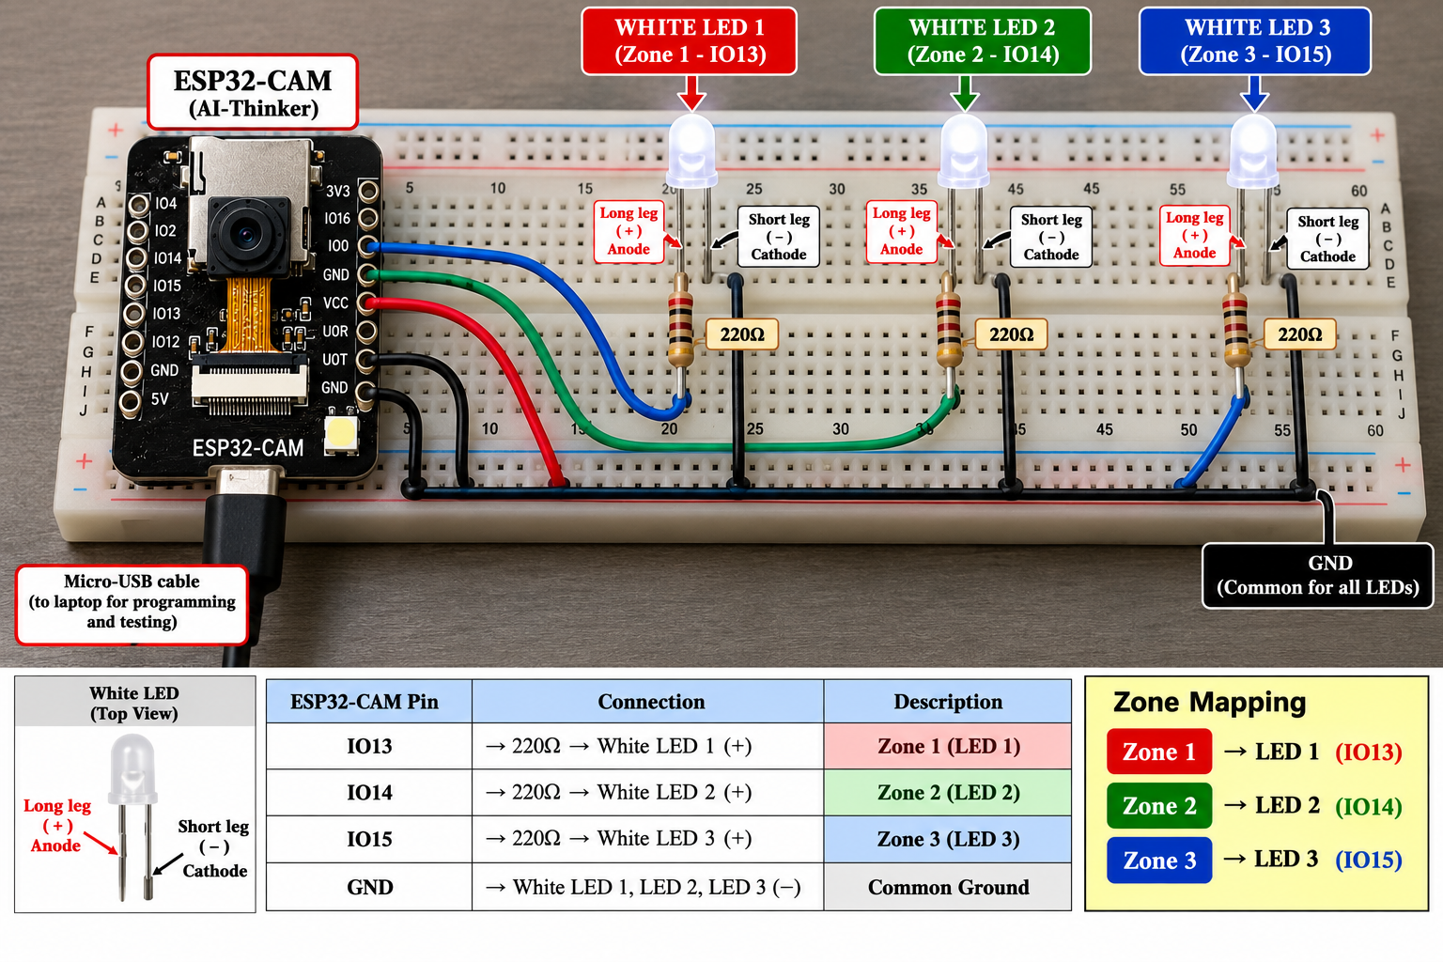
Fig. 3. Experimental planned setup of the proposed automated public-lighting system.

C. Vision and Motion-Tracking Pipeline
The OV2640 camera captures low-resolution image frames of the test track at set intervals. To keep compute requirements minimal, the system runs lightweight frame-differencing directly on the microchip, evaluating consecutive frames to isolate pixel-level changes caused by movement.
The total horizontal pixel space is split into three equal virtual bands. When pixel variations cross the sensitivity threshold, the algorithm calculates the average horizontal coordinates of the activity and assigns it to Zone 1, Zone 2, or Zone 3.
The planned mapping is:
Camera Region | Lighting Zone | LED
Left region | Zone 1 | LED 1
Center region | Zone 2 | LED 2
Right region | Zone 3 | LED 3
Rather than attempting object classification to distinguish pedestrians from vehicles or animals, the prototype strictly focuses on detecting significant localized movement and identifying its position within the field of view.
D. Ambient-Light Calibration
The analog LDR sensor evaluates surrounding illuminance before the adaptive lighting loop executes. An empirical threshold determines the boundary between adequate natural daylight and low-light conditions.
During daylight hours, the LEDs remain off or locked at a minimal state. Once natural light drops below the calibrated threshold, the microchip engages the adaptive vision loop. Because reading characteristics depend on sensor manufacturing variances and ambient room lighting, this threshold is fine-tuned experimentally on the physical testbed.
E. Adaptive Lighting Profile
Under low-light conditions with no movement detected, all three LED zones rest at a low-power standby intensity.
Upon detecting activity within a virtual zone, the ESP32-CAM immediately ramps up the corresponding LED array to maximum brightness. As the object transitions across the field of view, the newly targeted zone brightens while the trailing zone smoothly dims back to standby.
The resulting control sequence follows a distinct progression:
Low-Power Standby⟶Activity Detected⟶Active Zone Brightens⟶Target Moves⟶Trailing Zone Fades
This setup provides a clear visual demonstration of targeted, motion-following illumination.
F. Edge Processing and Network Offloading
The ESP32-CAM handles frame capture, motion differencing, zone mapping, and PWM LED driving entirely on-chip. As a result, the prototype operates as an independent edge node without relying on an external PC during deployment.
A workstation is used solely during the development phase to flash firmware, inspect serial telemetry, and debug code. For cloud connectivity, the board uses its onboard Wi-Fi module to sync ambient status, active zone logs, and motion events to a Firebase database. Crucially, cloud logging runs as a background task, ensuring network delays never interfere with real-time lighting control.
G. Experimental Testing Protocol
System validation follows a staged integration strategy. Initial tests confirm baseline hardware functionality—verifying individual camera frame capture, LED PWM response, and analog LDR readings across varying light levels.
Once individual subcircuits pass inspection, the complete system is assembled. The camera is aligned over the multi-zone track to observe controlled movement introduced sequentially across Zones 1, 2, and 3.
The experimental testing sequence encompasses:
- LED Verification: Validating PWM channel routing and brightness control for all three zones.
- LDR Calibration: Confirming reliable day/night threshold switching.
- Camera Initialization: Verifying frame stability from the OV2640 module.
- Zone Mapping: Testing spatial motion detection across Zones 1, 2, and 3.
- Adaptive Response: Verifying instant brightness scaling in the active zone.
- Transition Tracking: Evaluating light behavior as targets cross adjacent zone boundaries.
- Dimming Dynamics: Measuring the decay rate of trailing zones returning to standby.
- End-to-End Integration: Stress-testing the complete workflow under diverse operational conditions.
H. Performance Evaluation Metrics
System performance will be evaluated against key metrics, including zone-mapping accuracy, detection latency, ambient switching reliability, and control consistency.
We’ll evaluate the system based on its mapping accuracy, detection speed, switching reliability, and overall control consistency to keep performance smooth and predictable. By lighting only active zones and turning off empty ones, the setup cuts down on wasted energy compared to traditional, always-on lighting. Once the prototype is fully built, we’ll run bench tests to gather hard data on sensor accuracy and overall hardware performance before putting it into actual use.

VI. RESULTS AND DISCUSSION
A. Hardware and Component Testing
The proposed prototype will be evaluated through a structured, multi-stage testing process, starting with individual sub-circuit validation before moving to full system integration. Initial tests will verify the ESP32-CAM's boot sequence, ensuring stable OV2640 camera initialization and steady frame capture. Each of the three LED clusters will then be tested independently to confirm proper pin routing, PWM control, and distinct zone isolation.
Next, the LDR sensor module will be benchmarked under varying light conditions to map its analog response curve and fine-tune the day/night switching threshold. These isolated bench tests ensure every hardware sub-system is fully operational before executing the integrated adaptive control loop.
Quantitative readings and performance metrics will be formally recorded once physical prototype assembly is complete.
B. Ambient-Light Detection Results
The LDR-based ambient-light detection will be evaluated under different environmental conditions. The sensor readings obtained under bright and low-light conditions will be compared to determine an appropriate operating threshold. When the detected ambient light is above the selected threshold, the lighting system is expected to remain inactive or at its minimum state. When the ambient light falls below the threshold, the adaptive lighting operation is expected to become active. The actual LDR readings and selected threshold will be reported after experimental testing.
C. Camera-Based Activity Detection
The camera-based activity detection will be evaluated by introducing controlled movement into the monitored area. Consecutive frames captured by the OV2640 camera will be compared to identify significant changes in the scene.
Tests will be performed separately for the three virtual zones. Activity introduced into the left, centre, and right regions of the camera view is expected to be mapped to Zone 1, Zone 2, and Zone 3, respectively.
The evaluation will examine whether the system can consistently detect activity and correctly determine its approximate location.
D. Zone-Based Adaptive Lighting Results
The adaptive lighting behaviour will be evaluated based on the response of the three LED zones to detected activity. When activity is detected in a particular zone, the corresponding LED is expected to increase from the standby level. When activity moves away from that zone, the lighting level is expected to gradually decrease toward the standby state.
The experiment will verify whether the lighting response follows the intended sequence:
Low-intensity standby → Activity detection → Zone activation → Activity movement → Previous-zone reduction
The response of all three zones will be recorded during controlled movement experiments. The final results can be presented using a table showing the detected zone and corresponding LED response.
E. Integrated System Demonstration
After individual testing, the complete system will be evaluated under combined ambient-light and activity conditions. The ESP32-CAM will monitor the experimental area while the LDR determines whether the adaptive lighting mode should be active. Under low-light conditions, controlled movement will be introduced into different sections of the monitored area. The system will detect the activity, determine its approximate position, select the corresponding lighting zone, and adjust the LED output. The integrated demonstration will be used to verify that the proposed system can perform sensing, activity detection, zone selection, and lighting control as a continuous process without requiring an external computer during normal operation.
F. Monitoring and Cloud Communication
If Firebase integration is implemented successfully, the system will additionally be evaluated for transmission and storage of selected monitoring information. Possible parameters include ambient-light status, detected activity, active lighting zone, and lighting events. The cloud component will be evaluated as a monitoring and data-storage mechanism rather than as the primary real-time lighting controller. This allows the ESP32-CAM to continue performing the immediate lighting decisions locally.
G. Discussion
The expected experimental results will demonstrate whether a compact ESP32-CAM-based system can combine camera-based activity detection with localized adaptive lighting control. Unlike a conventional fixed-lighting approach, the proposed system is designed to increase illumination only in the zone where activity is detected while allowing previously activated zones to return toward a lower standby level. The use of virtual camera zones provides a simple method for associating detected activity with individual lighting sections without requiring a separate motion sensor for each zone. The LDR further prevents unnecessary adaptive-lighting operation under sufficient ambient-light conditions. The actual performance of the system will depend on factors such as camera placement, lighting conditions, frame-resolution settings, activity-detection thresholds, movement speed, and the physical arrangement of the LEDs. These factors will therefore be considered when interpreting the experimental results.
I. Experimental Results Summary
To make sure this prototype is truly ready, we’re going to run it through a series of tests across five key areas. We want to be really thorough, so for every single test we run, the team will be keeping track of four simple things.
First, we'll log the input conditions, which means capturing the exact environment or triggers we're throwing at the device. Next, we’ll note the expected outcome—basically, what should happen if everything works perfectly. Then, we’ll write down the actual result, which is just an honest look at how the prototype actually behaved. Finally, we'll mark the pass/fail status based on whether it did what it was supposed to do.
Tracking these four points will give us a really clear picture of what’s working great and exactly what we need to tweak for the next version.
Test | Expected Outcome | Status
Camera initialization | Stable image capture | To be updated
Left-zone motion | LED 1 activates | To be updated
Centre-zone motion | LED 2 activates | To be updated
Right-zone motion | LED 3 activates | To be updated
No detected motion | LEDs return to standby | To be updated
Day/night detection | Lighting responds to ambient light | To be updated
Cloud monitoring | Telemetry recorded when configured | To be updated
We’ll judge the system on its mapping accuracy, detection speed, switching reliability, and control consistency to make sure it runs without a hitch. By lighting up only active areas, we cut out energy waste compared to standard setup lights. Once the prototype is built, bench testing will give us the real data we need to verify sensor tuning and hardware performance before deployment.
VII. LIMITATIONS
The proposed system has several limitations. First, the current prototype uses lightweight frame-based activity detection rather than a trained machine-learning object-detection model. Therefore, the system is intended to identify significant movement or changes in the camera view rather than reliably distinguish between specific objects such as pedestrians, vehicles, or animals. Second, the prototype is designed as a small-scale three-zone demonstration. The physical arrangement of the camera and LEDs may differ significantly from an actual public road or large outdoor lighting installation. Camera performance can also be affected by environmental conditions such as poor illumination, shadows, glare, weather conditions, and objects that remain stationary within the monitored area. Third, the activity-detection method depends on suitable camera positioning and threshold selection. Changes that are too small may not be detected, while sudden environmental changes may potentially be interpreted as activity. Therefore, the detection threshold will need to be experimentally adjusted for the intended environment. The prototype also uses a limited number of lighting zones and LEDs. A real public-lighting deployment would require additional lighting units, suitable outdoor enclosures, electrical protection, and a more extensive communication and control infrastructure. Finally, Firebase and Wi-Fi communication are considered optional monitoring components. Network availability can affect cloud-based monitoring, although the primary lighting-control operation is designed to remain local to the ESP32-CAM.
VIII. CONCLUSION AND FUTURE WORK
This paper details the design and development of an automated, camera-based public lighting system using an ESP32-CAM, an OV2640 camera module, an LDR sensor, and three independently controlled LED zones. By applying lightweight frame-differencing, the system detects movement and maps it to specific zones, delivering localized high-brightness lighting only where needed instead of running full power everywhere continuously.
The architecture combines local image processing, ambient-light sensing, and adaptive LED control within a single compact embedded setup. While optional Wi-Fi and Firebase integration allow for remote logging and status tracking, the primary lighting controls operate completely independently of cloud connectivity.
System performance will be verified through hands-on testing of camera setup, motion detection, zone-mapping accuracy, day/night switching, and LED responsiveness. Experimental data will help assess overall system reliability, and energy consumption will be benchmarked directly against traditional fixed-brightness lighting.
Future work will focus on making motion detection more robust under changing light levels, expanding the number of control zones, finalizing cloud monitoring features, and running tests in real-world outdoor settings. We also plan to explore lightweight machine-learning models for object classification and evaluate broader deployment options.
Overall, this prototype offers a practical, low-cost approach to smart public lighting, with its full energy-saving potential to be validated through ongoing experimental testing.
REFERENCES
[1] S. P. Lau, G. V. Merrett, A. S. Weddell, and N. M. White, “A traffic-aware street lighting scheme for Smart Cities using autonomous networked sensors,” Computers & Electrical Engineering, vol. 45, pp. 192–207, 2015, doi: 10.1016/j.compeleceng.2015.06.011.
[2] M. Mahoor, Z. S. Hosseini, A. Khodaei, A. Paaso, and D. Kushner, “State-of-the-art in smart streetlight systems: A review,” IET Smart Cities, vol. 2, no. 1, pp. 24–33, 2020, doi: 10.1049/iet-smc.2019.0029.
[3] A. Omar, S. AlMaeeni, H. Attia, M. Takruri, A. Altunaiji, M. Sanduleanu, R. Shubair, M. S. Ashhab, M. Al Ali, and G. Al Hebsi, “Smart City: Recent Advances in Intelligent Street Lighting Systems Based on IoT,” Journal of Sensors, vol. 2022, Art. no. 5249187, 2022, doi: 10.1155/2022/5249187.
[4] M. Takruri, K. P. Thulasingam, H. Attia, A. Omar, A. Altunaiji, S. Almaeeni, M. Sanduleanu, R. Shubair, M. S. Ashhab, M. Al Ali, and G. Al Hebsi, “Design and Implementation of a Real-Time Street Light Dimming System Based on a Hybrid Control Architecture,” International Journal of Distributed Sensor Networks, vol. 2023, Art. no. 6641563, 2023, doi: 10.1155/2023/6641563.
[5] S. Khemakhem and L. Krichen, “A comprehensive survey on an IoT-based smart public street lighting system application for smart cities,” Franklin Open, vol. 8, Art. no. 100142, 2024, doi: 10.1016/j.fraope.2024.100142.
[6] V. Križanović, K. Grgić, A. Pejković, and D. Žagar, “Energy Savings in Public Lighting by Using Adaptive Street Lighting—A Framework for Energy-Savings Assessment and Machine Learning-Based Evaluation,” Applied Sciences, vol. 16, no. 16, Art. no. 7917, 2026, doi: 10.3390/app16167917.
[7] S. D., V. Sagar K. S., and S. Sushmitha, “A Survey on IOT based Real Time, Smart Adaptive Street Lighting System with Pollution Monitoring for Smart Cities,” International Journal on Recent and Innovation Trends in Computing and Communication, vol. 7, no. 1, pp. 21–26, 2019, doi: 10.17762/ijritcc.v7i1.5221.
[8] T. E. Achar, C. Rekha, and J. Shreyas, “Smart automated highway lighting system using IoT: A survey,” International Journal of Electrical and Computer Engineering, 2024.
[9] A. F. Mohamed, A. A. Ali, A. Benmouna, H. Ramadan, and N. F. Omran, “IoT-Enabled Smart Street Lighting: A Bibliometric-Driven Review of Energy-Efficient Architectures and Environmental Integration,” Information, vol. 17, no. 6, Art. no. 596, 2026, doi: 10.3390/info17060596.
[10] S. Lau, G. Merrett, A. Weddell, and N. White, “Energy-efficient adaptive street lighting using networked sensing and intelligent control,” related work on traffic-aware adaptive street lighting, Computers & Electrical Engineering, 2015.
[11] R. C. Gonzalez and R. E. Woods, Digital Image Processing, 4th ed. Pearson, 2018.
[12] B. K. P. Horn and B. G. Schunck, “Determining optical flow,” Artificial Intelligence, vol. 17, no. 1–3, pp. 185–203, 1981, doi: 10.1016/0004-3702(81)90024-2.
[13] B. D. Lucas and T. Kanade, “An iterative image registration technique with an application to stereo vision,” in Proc. 7th International Joint Conference on Artificial Intelligence (IJCAI), Vancouver, Canada, 1981, pp. 674–679.
[14] G. Bradski and A. Kaehler, Learning OpenCV: Computer Vision with the OpenCV Library. O’Reilly Media, 2008.
[15] R. Szeliski, Computer Vision: Algorithms and Applications, 2nd ed. Springer, 2022, doi: 10.1007/978-3-030-34372-9.
[16] Espressif Systems, “ESP32 Series Datasheet,” Espressif Systems, technical documentation. [Online]. Available: https://www.espressif.com/sites/default/files/documentation/esp32_datasheet_en.pdf
[17] Espressif Systems, “ESP32 Camera Driver,” ESP32 Arduino Documentation, Espressif Systems. [Online]. Available: https://github.com/espressif/arduino-esp32/tree/master/libraries/ESP32/examples/Camera
[18] OmniVision Technologies, “OV2640 CameraChip Sensor,” OV2640 Datasheet, OmniVision Technologies, technical documentation.
[19] Google Firebase, “Firebase Realtime Database Documentation,” Google Firebase. [Online]. Available: https://firebase.google.com/docs/database
[20] International Commission on Illumination (CIE), Lighting of Roads for Motor and Pedestrian Traffic, CIE 115:2010, Commission Internationale de l'Éclairage, 2010.

* * *

